To be completed by Local PTA after receipt of Reflections Artwork.
Category
(D, F, L, M, P, V)
Division
(P, I, M, H, SA)
Member Dues Paid Date
Bylaws Approval Date
Entry Date Nat’l PTA Portal
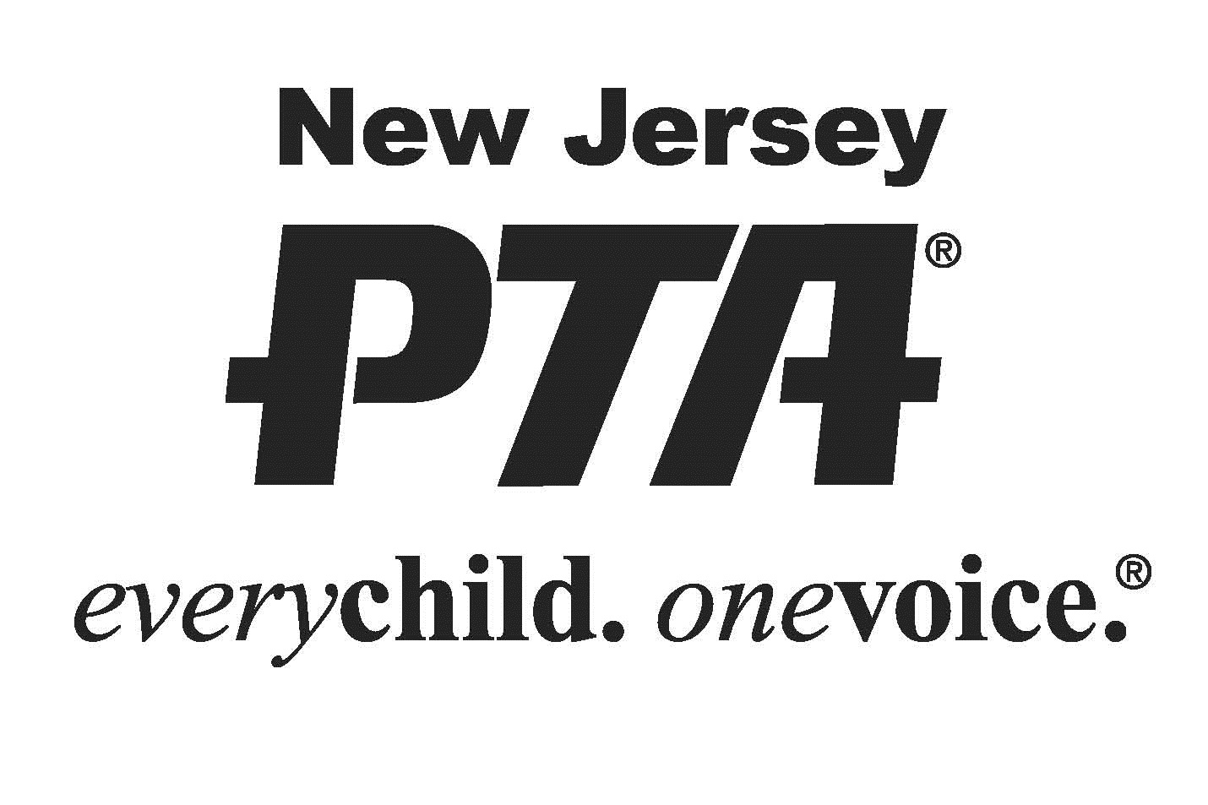
NJPTA 2018-2019 REFLECTIONS
ENTRY FORM

To be completed by Local PTA before distribution.
LOCAL PTA __________________________________________ LOCAL PTA ID ___ ___ ___ ___ ___ ___ ___ ___
LOCAL PROGRAM CHAIR___________________________ EMAIL/PHONE______________________________
COUNTY PTA_______________ DISTRICT PTA_______________ REGION PTA_______________ STATE PTA: NJ

STUDENT NAME _______________________________ GRADE ______ AGE ______ CLASSROOM __________
PARENT/GUARDIAN NAME ______________________ EMAIL ________________ PHONE ________________
MAILING ADDRESS _____________________________ CITY ______________ STATE _________ ZIP _______
Ownership in any submission shall remain the property of the entrant, but entry into this program constitutes entrant’s irrevocable permission and consent that PTA may display, copy, reproduce, enhance, print, sublicense, publish, distribute and create derivative works for PTA purposes. PTA is not responsible for lost or damaged entries. Submission of entry into the PTA Reflections program constitutes acceptance of all rules and conditions. I agree to the above statement and the National PTA Reflections Official Rules.

STUDENT SIGNATURE _______________________ PARENT/GUARDIAN SIGNATURE ____________________

GRADE DIVISION (Check One) ARTS CATEGORY (Check One)
PRIMARY (Pre-K-Grade 2) DANCE CHOREOGRAPHY
INTERMEDIATE (Grades (3-5) FILM PRODUCTION
MIDDLE SCHOOL (Grades 6-8) LITERATURE
HIGH SCHOOL (Grades 9-12) MUSIC COMPOSITION
SPECIAL ARTIST (All Grades) PHOTOGRAPHY
VISUAL ARTS

TITLE OF WORK ____________________________________________ DETAILS _________________________
If background music is used in dance/film, citation is required. Include word count for literature. List musician(s) or instrumentation for music. List dimensions for photography/visual arts.
ARTIST STATEMENT (In 10 to 100 words, describe your work and how it relates to the theme)
__________________________________________________________________________________________
__________________________________________________________________________________________
__________________________________________________________________________________________
__________________________________________________________________________________________
__________________________________________________________________________________________

