SPIRIT WEAR ORDER FORM
T-Shirts (Short Sleeve) - $12 each
Black AS______ AM______ AL ______ AXL______
Blue AS______ AM______ AL______ AXL______

Hooded Sweatshirts - $28 each
Black AS______ AM______ AL______ AXL______
Blue AS______ AM______ AL______ AXL______

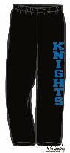
Sweatpants - $20 each
Black AS______ AM______ AL______ AXL______

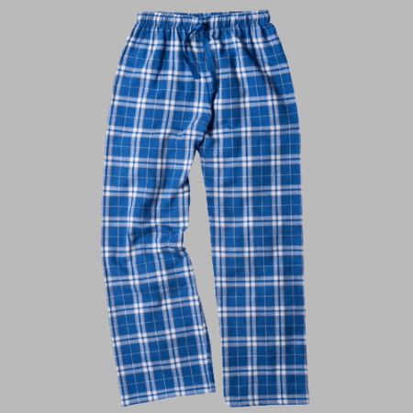
Flannel Pants - $23 each
Blue/Silver AS______ AM______ AL______ AXL______

~~~~~~~~~~~~~~~~~~~~~~~~~~~~~~~~~~~~~~~~~~~~~~~~~~~~~~~~~~~~~~~~~~~~~~~~~~~~~~~~~~~~~~~
Student Name: ______________________________ Total Enclosed: __________
Grade: _____ Homeroom Teacher: ____________________________________
Email / Phone ____________________________________________________________
Please return this form with payment (cash or check payable to: “HSN PTSA”). Please put the form and payment in a sealed envelope marked with your child’s name and “HSN Spirit Wear”. Questions please contact Louise Dyke at loudyke@hotmail.com.

